Name: Aneeq Bokhari

Java project
Vehicle Rental System

Table of Contents
Introduction to the Application 2
List of User Stories 2
1. List All Vehicles 3
2. View Available Vehicles 3
3. View Details Of A Specific Vehicle 3
4. Create A Booking 4
5. Prevent Double-Booking 5
6. List All Bookings 5
7. Exit The Program 6
UML 6
List of all Java classes 7
Evaluation 9

Introduction to the Application

For this project, I built small console-based called Vehicle Rental Application, written in Java. The application allows a user to view vehicles, check availability, and create bookings. Each booking records start/end times and pricing. The focus was on implementing class design, inheritance, interfaces, exception handling, and use of modern java features such as sealed classes, records, enum, lambdas, predicates, switch expressions and defensive copying.

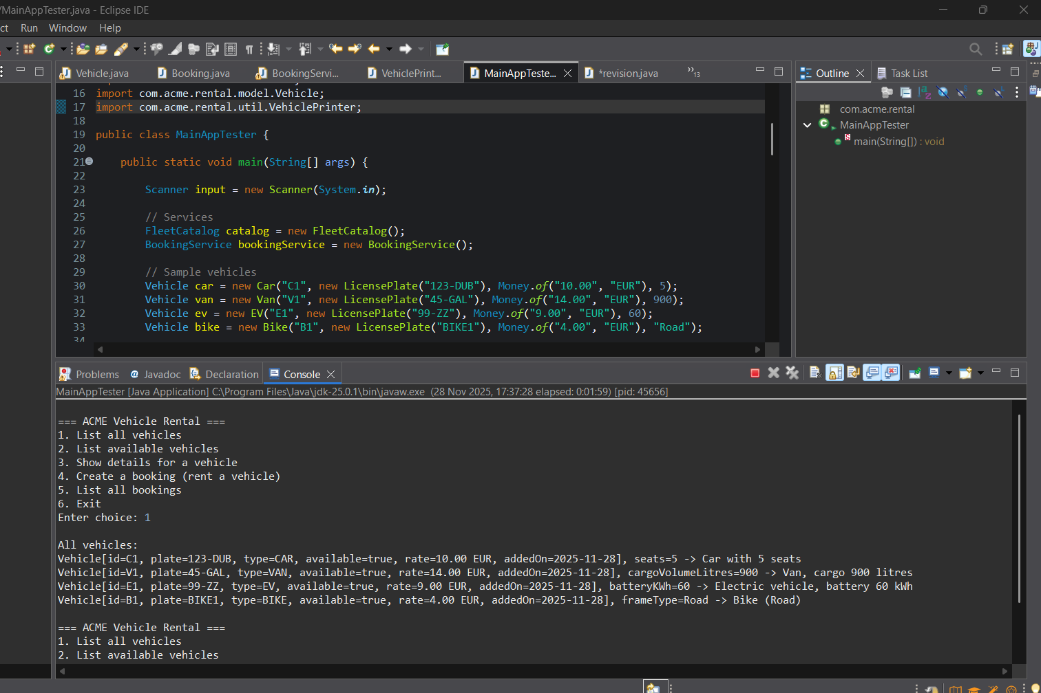
Figure 1: Main Application Tester (MainAppTester.java) class and the output of the menu

List of User Stories
These are the main user stories implemented in the Vehicle Rental System:
- List all vehicles
- View available vehicles
- View details of a specified vehicle
- Create a booking
- Prevent double booking
- List of all bookings
- Exit the Program

List All Vehicles
- As a user, I want to view all vehicles in the system so that I can what the company offers.

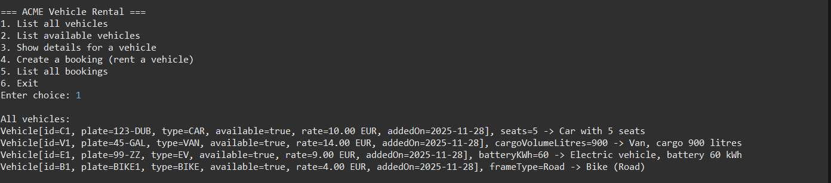
Figure 2: Output showing list of all vehicles when user enter choice 1

View Available Vehicles
- As a user, I want to see only vehicles that are currently available so that I know which ones I can rent right now.

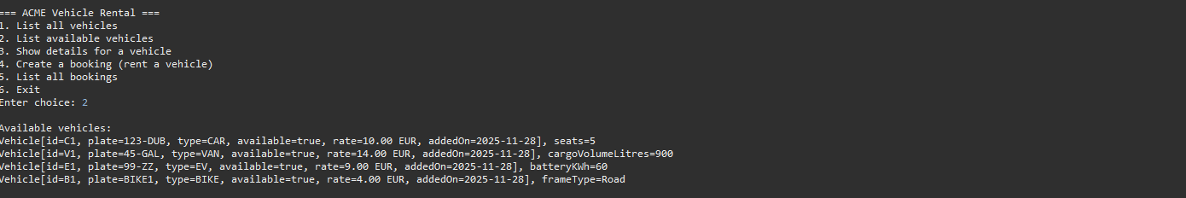
Figure 3: Output showing list of available vehicles when user enter choice 2

View Details Of A Specific Vehicle
- As a user, I want to enter a vehicle ID and view its details so that I can check its types, features, and status.
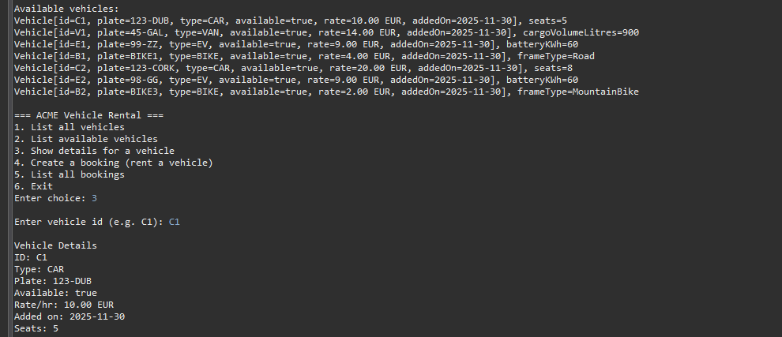
Figure 4: Output showing specific details of the vehicle when user enter choice 3

Create A Booking
- As a user, I want to rent a vehicle for a number of hours so that I can reserve it and calculate the price.

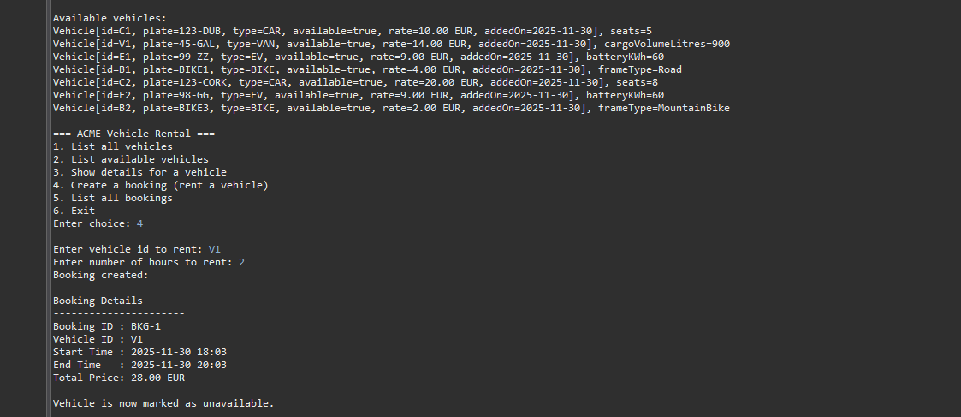
Figure 5: Output showing when booking is created of the vehicle when user enter choice 3

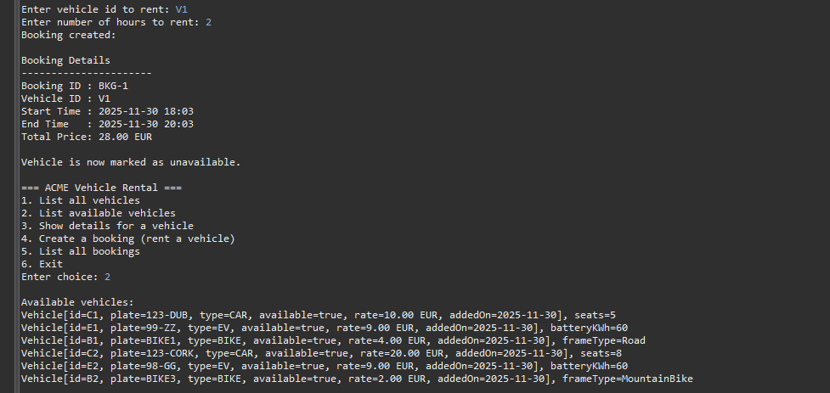
Figure 5.1: Output showing the updated list of available vehicles when user enter choice 2 (after booking was created for V1-Van)

Prevent Double-Booking
- As a user, I want the program to stop me from renting a vehicle that is already booked so that I don’t accidentally rent unavailable vehicles.

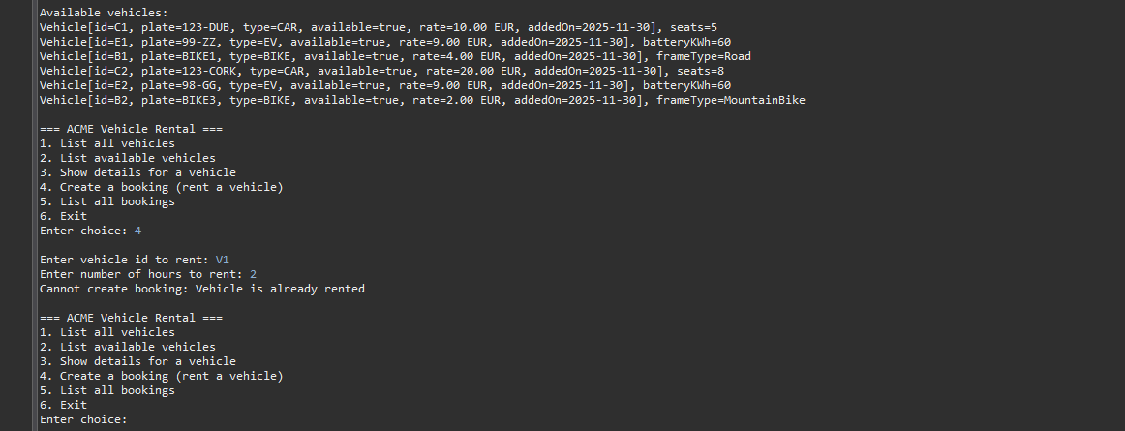
Figure 6: Output showing the that vehicle(v1) cannot be created because it is already rented when user enter choice 4 (again for the same vehicle)

List All Bookings
- As a user, I want to view all bookings so that I can see rental history and verify that my booking was created.

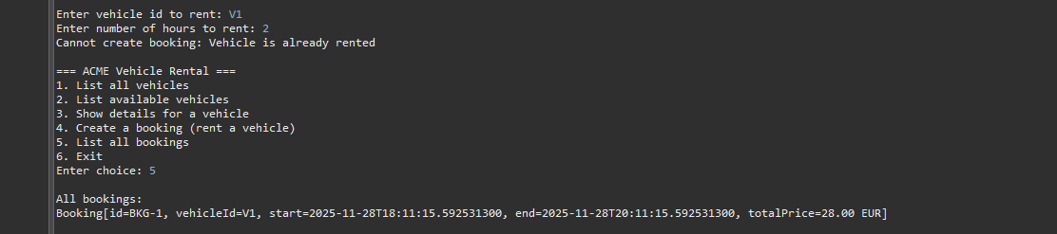
Figure 7: Output showing the list of all bookings (BKG) when user enter choice 5

Exit The Program
- As a user, I want to an option to exit so that I can end my session cleanly.
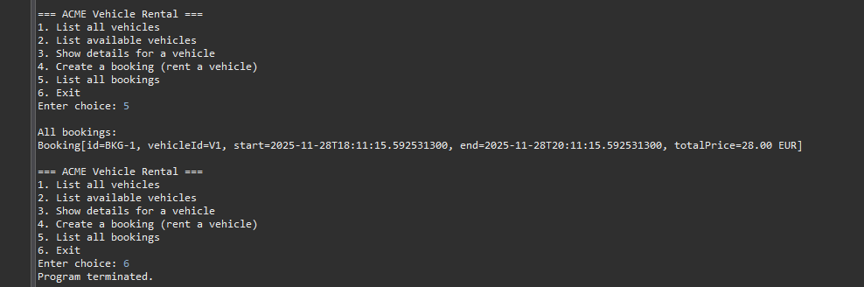
Figure 8: Output the program is terminated after user enter choice 6

UML
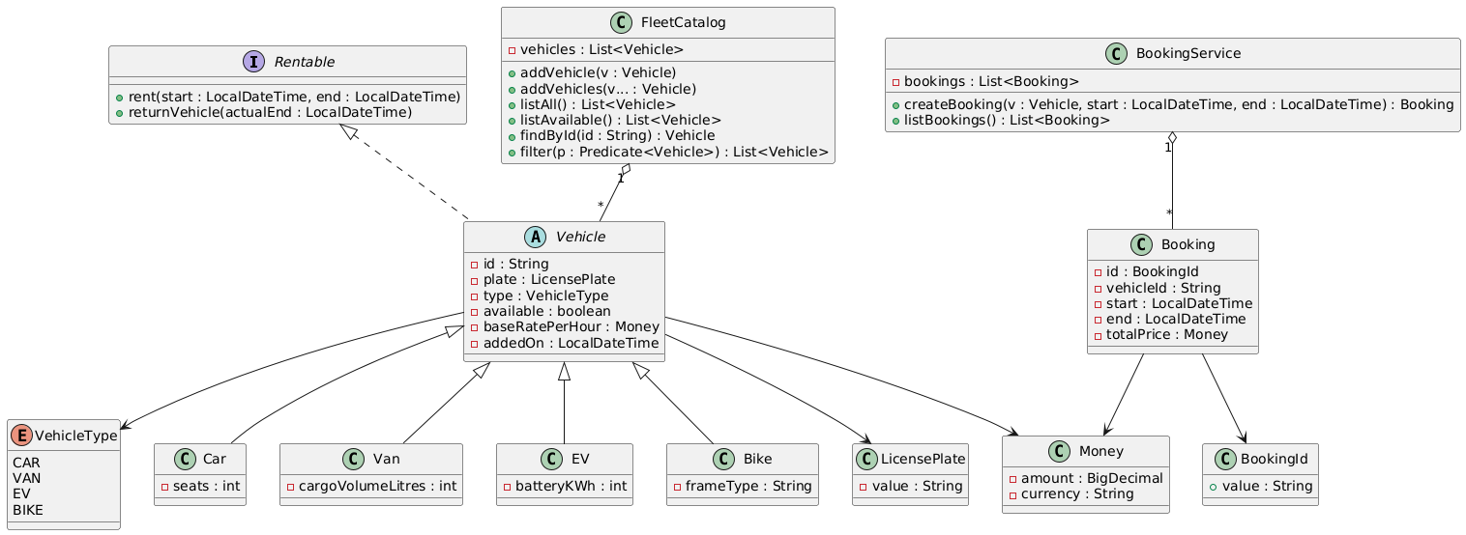
Figure 9: UML Diagram of Vehicle Rental Application

The UML diagram (Figure 9 above) represents the structure of the Vehicle Rental System and shows how the main components of the application interact.
At the centre of the model is the abstract Vehicle class, which defines the shared properties of all vehicles (ID, license plate, type, availability, base hourly rate, and dates). It is marked as abstract and sealed, meaning it cannot be instantiated directly and only a fixed set of subclasses are allowed. The permitted subclasses are Car, Van, EV, and Bike, each adding one field specific to its category (e.g., seats for Car, battery capacity for EV, etc.). The system also uses a VehicleType enum to classify the type of each vehicle.
Vehicles implement the Rentable interface, which provides the contract for renting and returning a vehicle. This allows the system to enforce consistent rental behaviour across all vehicle types.
Vehicles are managed by the FleetCatalog class, which maintains a list of available vehicles and provides operations such as adding vehicles, searching by ID, listing available vehicles, and filtering using predicates.
Bookings are represented by the Booking record, which stores the booking ID, the vehicle ID, start and end times, and the total calculated price. Supporting value objects include BookingId, Money, and LicensePlate, each ensuring strong validation and encapsulation of commonly reused data.
The BookingService is responsible for creating bookings, calculating the rental price (delegating to PricingService), and marking vehicles as rented. The service also maintains a list of all bookings created during the execution of the program.
Overall, the UML diagram shows a modular, object-oriented system with strong separation of concerns: vehicles and fleet management, booking operations, pricing logic, and validated value objects.

List of all Java classes

Model / Domain
- Vehicle (abstract- sealed)
- VehicleType (enum)
- Car (subclass of Vehicle)
- Van (subclass of Vehicle)
- EV (subclass of Vehicle)
- Bike (subclass of Vehicle)
- Rentable (interface implemented by vehicles)
- FleetCatalog (stores and manages vehicles; filtering/search/listing)
- Booking (record)
- BookingId (class)
- Money (value object for price/currency)
- LicensePlate (value object)

Services / Application logic

- BookingService (creates bookings, marks vehicles rented, keeps bookings list)
- PricingService (calculates total price / pricing rules)

Utility / Types
- VehiclePrinter (Helper to format and print vehicles details neatly)

Exception / Error handling

- FleetOperationException (Use for enexpected runtime errors in fleet operations)
- VehicleNotAvailableException (Use when a caller attempts to renta vehicle that is already rented or otherwise unavailable.

Testing the Program

- MainAppTester (or Main) - Test and run the Java Application (Program)

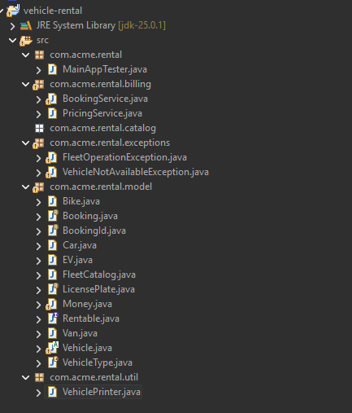
Figure 10: Showing the List of all Java Classes in the project

Evaluation

Overall, the Java Application works as expected and meets the main requirements. I was able to create bookings, store the booking details, and display them correctly through the Booking class. The code follows basic oriented principles such as encapsulation and using getters. Setters.
When working on the project, I tested the main features to make sure the input was handed correctly and that the Java Application behaved as intended. The tests showed that the system works, but there are still some areas that could be improved. For example, the application could have better validation for incorrect or missing data and more informative error messages.
If I had more time, I would also improve the user application interface, add more features such as updating or cancelling bookings and make the code more reusable. Overall, the Project helped me understand Java classes, constructors, Arrays, and how to structure a small application.

